SOUTHEAST GIRLS SOFTBALL LEAGUE
Rule 2022 - U11
Long-Term Athlete Development
The Southeast Girl Softball League has been engaged in a major review of programs to develop an athlete-centered system. This will ensure we provide the optimal training, competition and recovery programs for athletes at each stage of their development. This program is sport-science based, developmentally appropriate, driven by our coaches and strongly supported by our administrators. The plan is also supported by many of Canada’s High-Performance baseball players, including Colorado Rockies pitcher Jeff Francis and former Anaheim Angel Jason Dickson. The initial report to Baseball Canada by the project team can be found at http://www.baseball.ca/files/ltad.pdf. General sport science information is available at www.ltad.ca.
Mites (U10)
The LTAD plan identifies 7 stages in respect to the athletes physical, mental, and emotional development. Mite aged baseball players are in stage 2, which is the FUNdamentals stage of the LTAD plan. Coaches are reminded that children at this level need to participate in activities that develop basic skills. These activities need to maintain a focus on fun, and formal competition should only be minimally introduced.
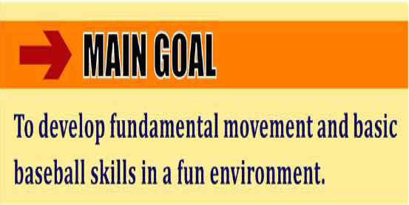
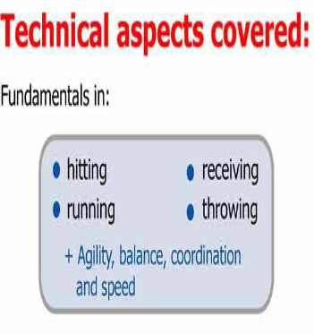
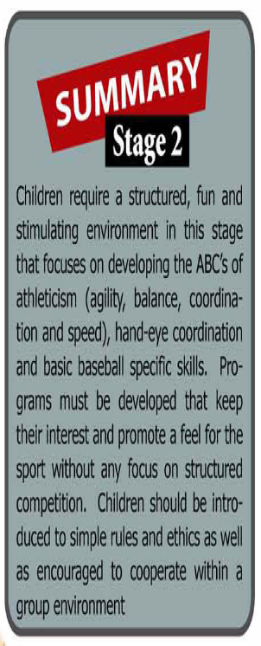

U11 Rules (2022)

Distance from home plate to pitching mount * 30’ in May and 35’ in June!
Distance from home plate to 1st and 3rd base (55’)
- Play for fun / Coaches are required to encourage fair play
- Coach on the defensive team should stand behind catcher, near backstop.
- Pitcher is only allowed to pitch 2 innings per game 5 Inning Game.
- NEW !!! – Please use “BIG ORANGE PLATE” for home plate, this is to enlarge the batters strike zone, to encourage the batters to swing and will also allow the pitcher to throw more strikes.
- No Walking – Hitting off the tee !!!
- Once the batter has received 4 balls in the count she will attempt to hit the ball off a batting tee. (A coach can positively reinforcement this to players by explaining that they were able to show the skill necessary to get a walk, they now get the great chance of getting an easy ball to hit off the tee.)
- The batting tee will be placed in front of home plate by the coach of the hitting team. Once the ball is hit, the coach (of the hitting team) as unobtrusive as possible, will remove the tee and place it by the fence near the on-deck circle.
TEE PLACEMENT- Most Tees are made incorrectly, with the ball in the middle of the plate. The ball should be placed on the front of Homeplate, so the batters are hitting the ball out in front of the plate.
- The batter will be provided with three attempts to hit a fair ball off the tee. A fair ball will consist of the following expectations:
  - The ball travels at least 10 feet. (umpires discretion. If he/she feels it is not 10 feet they will yell foul ball).
  - The hit is what would be considered a fair ball in a regular hitting situation (stays between the foul lines).
- If not one of the batters three attempts is considered fair, as explained in rule 3, she will be called out after the third attempt. An attempt is considered any swing at the ball on the tee. Ex. Swing and a miss is an attempt, swing and hit the tee only is an attempt.
- The pitcher is allowed to stand behind the mound (10 feet should suffice) during the Tee hitting, but can not come closer to home plate. This rule is to provide safety for the pitcher in the event that it is a powerful hitter at the plate.
- The home team provides a batting tee, although it is a good idea for both teams to have one in the case of the original tee breaking.
(Applies to SEGSL League and Play offs)
- Teams will consist of 6 Players (Max 8), ideal team would have, pitcher, catcher & 4 infielders. Teams that have more than 6 players can bat through the rotation, but can only send up to 7 fielders out in the field (Catcher, Pitcher & 4 infielders + 1 Center Field).
- Masks and Helmets are mandatory – including parents, coaches and catchers on or off the diamond if catching for a pitcher.
- Highly Recommended that players in the infield wear face masks during SEGSL play
- Batter may not run to 1st on any 3rd strike
- NO STEALING Runners are not allowed to steal bases in U11. We want to create more defensive play opportunities to develop the defensive side of the game.
- NO RUNNING ON OVER THROWS - To encourage defensive plays, the runner can not run on any overthrows. If the Batter connects for a solid hit into the out field, she is allowed to run around the bases until the defensive team returns the ball into the infield and the coaches should call to the runner to stop running. If the Hitter hits the ball in the infield, that player should be attempting to beat the throw to 1st base, she should not attempt to keep running to other bases. This will encourage fielders to develop their throws to specific bases and make plays without being penalized for trying make a play. It will help teach the players some of the strategy involved at the defensive end of the game.
-11” outdoor ball is used
-3 outs or 5 RUNS to end an inning
-Official scores are not recorded or sent to the league
- Coaches - please have you players hustle on and off the field
- Find a volunteer parent or coach as a bench boss … help get the kids ready with helmets, hats, gloves.
– Have your hitting / defensive line-up ready for every inning or rotate positions as you go.
- Temporary Runner for the catcher & pitcher rule is mandatory after two outs. this is to speed up the game and have your pitcher / catcher ready for the upcoming defensive side of the inning. * Must use the player who’s furthest away on the batting line-up.
- Please ask your team to arrive a minimum of 30 Minutes prior to game time. Game time starts at 6:30PM, ***No new inning started after 8:00pm. If teams want an infield … the home team will have access to the infield 25 minutes prior to the game, away team gets the infield 15 minutes prior to game time. (10 Minute Infield)
- If an ump is not present, a parent ump volunteer may ump the game. It is at the umpire’s discretion to determine if the game is over by weather and sunlight. Parent ump must have knowledge of the game and be provided with league rules
These are Southeast Girls Softball League rules. The SEGSL play off tournament will follow these rules.
If attending outside tournaments or provincials – please note those rules will be different.
Please Note:
The Steinbach Storm Classic will follow the same rules as provincials unless otherwise stated upon registration -- not the SEGSL rules.

