SOUTHEAST GIRLS SOFTBALL LEAGUE
2022 Rules - U13
Long-Term Athlete Development
The Southeast Girl Softball League has been engaged in a major review of programs to develop an athlete-centered system. This will ensure we provide the optimal training, competition and recovery programs for athletes at each stage of their development. This program is sport-science based, developmentally appropriate, driven by our coaches and strongly supported by our administrators. The plan is also supported by many of Canada’s High-Performance baseball players, including Colorado Rockies pitcher Jeff Francis and former Anaheim Angel Jason Dickson. The initial report to Baseball Canada by the project team can be found at http://www.baseball.ca/files/ltad.pdf. General sport science information is a available at www.ltad.ca.
U12 Squirts - The LTAD plan identifies 7 stages in respect to the athletes physical, mental, and emotional development. Squirts Aged baseball players fall into stage 3 of the LTAD plan which is the “Learning to Train” level. Coaches are reminded that athletes at this level should be encouraged to have fun, learn sportsmanship, and develop sport specific skills (Throwing, Catching, Hitting). Learning to win and focusing on a specific position should not occur at this level, but in future years as the child has had the chance to further develop as an athlete .

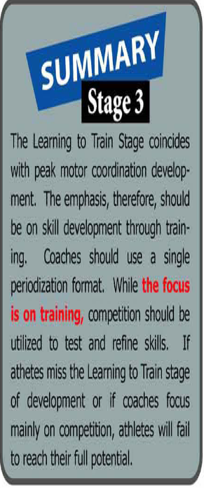

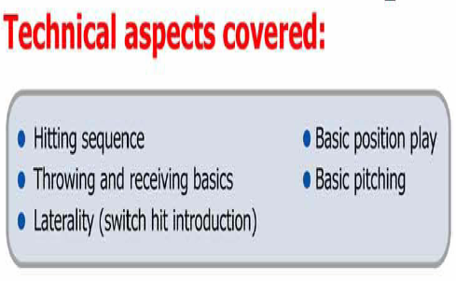

U13 Rules (2022)
Pitching Distance: 38’ / Base Distance : 55’
- Play for fun / coaches are required to encourage fair play Remember these are exhibition games and we encourage development
- Please use “BIG ORANGE PLATE” for home plate, this is to enlarge the batters strike zone, to encourage the batters to swing and will also allow the pitcher to throw more strikes.
- Pitchers can only throw 2 innings per a 4 inning game. If the game extends to the 5th inning, the pitcher will be allowed a 3rd inning, but can only pitch a maximum 3 innings for that specific pro-longed game (Game must have 5 innings or more to extend pitcher to 3 innings).
- Roster Batting – all players must be placed in the line-up. Defensive substitutions, other than pitching, are unlimited. Injured players are removed from the line-up and an out is NOT recorder in their spot in the order.
- Batter may not run to 1st on 3rd strike if the ball is dropped
-12” Rawlings Red Dot
-3 outs or 5 runs end an inning, NO OPEN INNINGS AT ALL
- No Walking – Hitting off the tee !!!
- Once the batter has received 4 balls in the count he/she will attempt to hit the ball off a batting tee. (A coach can positively reinforcement this to players by explaining that they were able to show the skill necessary to get a walk, they now get the great chance of getting an easy ball to hit off the tee.)
- The batting tee will be placed in front of home plate by the coach of the hitting team. Once the ball is hit, the coach (of the hitting team) as unobtrusive as possible, will remove the tee and place it by the fence near the on-deck circle.
TEE PLACEMENT- Most Tees are made incorrectly, with the ball in the middle of the plate. The ball should be placed on the front of Homeplate, so the batters are hitting the ball out in front of the plate.
- The batter will be provided with three attempts to hit a fair ball off the tee. A fair ball will consist of the following expectations:
  - The ball travels at least 10 feet. (umpires discretion. If he/she feels it is not 10 feet they will yell foul ball).
  - The hit is what would be considered a fair ball in a regular hitting situation (stays between the foul lines).
- If not one of the batters three attempts is considered fair, as explained in rule 3, she will be called out after the third attempt. An attempt is considered any swing at the ball on the tee. Ex. Swing and a miss is an attempt, swing and hit the tee only is an attempt.
- The pitcher is allowed to stand behind the mound (10 feet should suffice) during the Tee hitting, but can not come closer to home plate. This rule is to provide safety for the pitcher in the event that it is a powerful hitter at the plate.
- The home team provides a batting tee, although it is a good idea for both teams to have one in the case of the original tee breaking.
(Applies to SEGSL League and Play offs)
- PLAYERS MAY ONLY SCORE FROM 3RD ON A BATTED BALL:
Baserunners may not steal home, may not score on a past ball or wild pitch, may not score on an overthrow from the catcher to the pitcher or to any player on the field, and may not score because of an overthrow by a defensive player. This is a new SEGSL rule and is in effect for all games.
The purpose of the rule is to speed up the game and build the players skill and enjoyment levels as there are:
a. no worries about the runner at third scoring on a throw back to the pitcher.
b. no worries about a run scoring because of a past ball or pitcher’s wild pitch.
c. no worries about the runner at third trying to steal home
d. no risks and therefore more attempts for catchers to throw baserunners out.
- NO RUNNING ON OVER THROWS
a) To encourage defensive plays, the runner can not run on any overthrows. If the Batter connects for a solid hit into the out field, she can run around the bases until the defensive team returns the ball into the infield and the coaches should call to the runner to stop running. If the Hitter hits the ball in the infield, that player should be attempting to beat the throw to 1st base, she should not attempt to keep running to other bases. This will encourage fielders to develop their throws to specific bases and make plays without being penalized for trying make a play. It will help teach the players some of the strategy involved at the defensive end of the game.
b) Stealing bases are legal, however, runners can not run on an overthrow. This will encourage catchers to develop their throws to specific bases and fielders to practice catching and tagging the runners.
- Please ask your team to arrive 1 hour prior to game time. Game time starts at 6:30PM, ***No new inning started after 8:30pm. If teams want an infield … the home team will have access to the infield 25 minutes prior to the game, away team gets the infield 15 minutes prior to game time. (10 minute infield)
- If an ump is not present, a parent ump volunteer may ump the game. It is at the umpire’s discretion to determine if the game is over by weather and sunlight.
-Parent ump must have knowledge of the game and be provided with league rules
- Masks and Helmets are mandatory – including parents, coaches and catchers on or off the diamond if catching for a pitcher. It’s also highly recommended that players in the infield wear face masks games.
- All players rotate through the batting order and defensively you can move players around at any time.
- Temporary Runner for the catcher & pitcher rule is mandatory after two outs. this is to speed up the game and have your pitcher / catcher ready for the upcoming defensive side of the inning. * Must use the player who’s furthest away on the batting line-up.
- Please have your players hustle on and off the field.

These are Southeast Girls Softball League rules. If attending outside tournaments or provincials – please note those rules may be different.

