SOUTHEAST GIRLS SOFTBALL LEAGUE
U9 Rules 2022
Long-Term Athlete Development
The Southeast Girl Softball League has been engaged in a major review of programs to develop an athlete-centered system. This will ensure we provide the optimal training, competition and recovery programs for athletes at each stage of their development. This program is sport-science based, developmentally appropriate, driven by our coaches and strongly supported by our administrators. The plan is also supported by many of Canada’s High-Performance baseball players, including Colorado Rockies pitcher Jeff Francis and former Anaheim Angel Jason Dickson. The initial report to Baseball Canada by the project team can be found at http://www.baseball.ca/files/ltad.pdf. General sport science information is available at www.ltad.ca.
The LTAD plan identifies 7 stages in respect to the athletes physical, mental, and emotional development. Mite aged baseball players are in stage 2, which is the FUNdamentals stage of the LTAD plan. Coaches are reminded that children at this level need to participate in activities that develop basic skills. These activities need to maintain a focus on fun, and formal competition should only be minimally introduced.

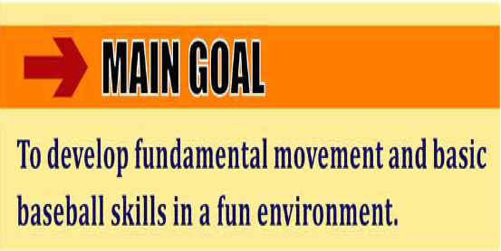
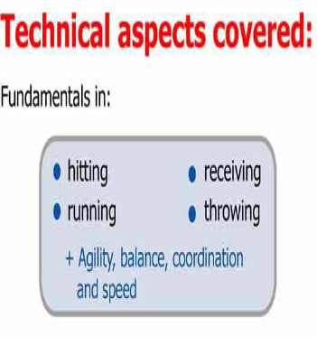
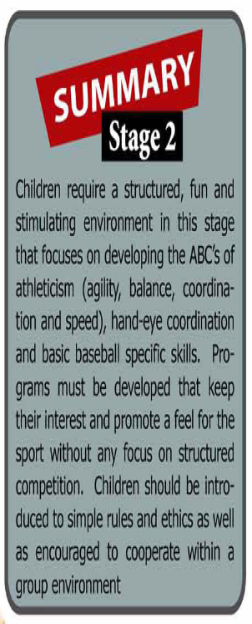

SOUTHEAST GIRLS SOFTBALL LEAGUE
U9 Rules – 2022
Distance from home plate to pitching mount 9.14 m (30’) *Coaches discretion
Distance from home plate to 1st and 3rd base 13.7 m (45’)
- Suggested Time to be at the diamond by 6PM for warm up, start time for the game at 6:30PM - do not start another inning past 7:30PM (ideally 1 hour games)
- Play for fun
-Parent pitch, after 5 pitches batter will hit off of a tee **Everyone hits**
-Parent catches
-11” indoor balls
- No stealing
- NO RUNNING ON OVER THROWS - To encourage defensive plays, the runner can not run on any overthrows. If the Batter connects for a solid hit into the out field, she is allowed to run around the bases until the defensive team returns the ball into the infield and the coaches should call to the runner to stop running. If the Hitter hits the ball in the infield, that player should be attempting to beat the throw to 1st base, she should not attempt to keep running to other bases. This will encourage fielders to develop their throws to specific bases and make plays without being penalized for trying make a play. It will help teach the players some of the strategy involved at the defensive end of the game.
- All players bat once per inning
- If a batter or runner is put out on a base, they do not continue to run, if runner is put out on the play, they are out and head back to the dug out.
- No score
- 5-7 players on the field
- Fielding coach optional
- Please have the players hustle on and off the field
- Find a volunteer parent as a bench boss … help get the kids ready with helmets, hats, gloves.
– Have your hitting / defensive line-up ready for every inning or rotate positions as you go.

